**DEVOPS PROJECTS - 1**

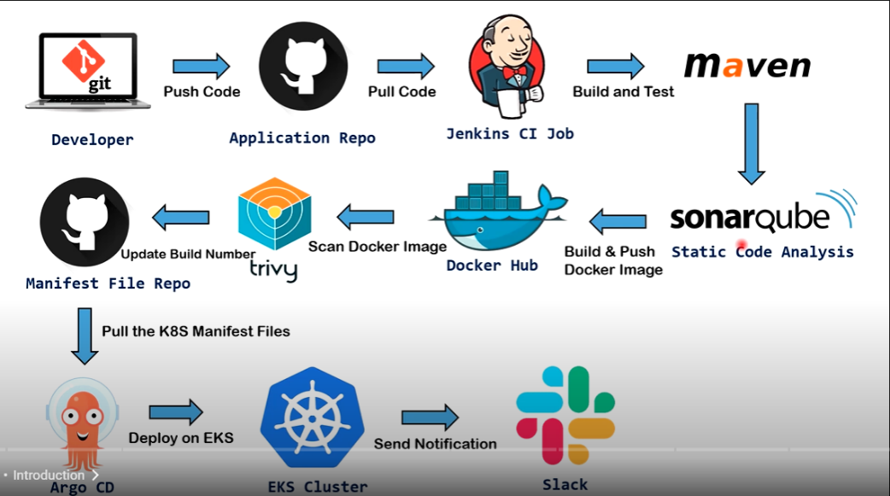

**Install and Configure Jenkins Master and Agent:**

**Step-1**

* Create 2 virtual machines in the AWS of Ubuntu OS. Jenkins-Master and Jenkins-Agent
* Login to each server in the mobaXterm.
* sudo nano /etc/hostname

Replace the IP address with Jenkins-Master and Jenkins-Agent in the respective VMs.

Ctrl+ X --- to save and exit >> Enter.

Sudo init 6 ---Reboot the servers

* sudo apt update && apt upgrade in both servers.
* Install jdk from the documentation and then the Jenkins weekly release also in the Master Node.
* Install jdk and docker in the Agent Node.
* sudo usermod -aG docker $USER
* sudo init 6 –Reboot the server

**Step-2:**

* sudo nano /etc/ssh/sshd_config

uncomment the below

Pubkey Authentication yes

AuthorizedKeyfiles .ssh/

* Do the above for both Master and Agent Nodes

**Step-3:**

* Now in the master node.
* ssh-keygen
* click enter for all and the public and private keys are created in the Master node.
* cd .ssh/ >> ls
* This gives the public, private and authorized keys of the Master node.
* Copy the public key of the master node.
* Now in the Agent node cd .ssh/ >> ls
* Paste the key in the Authorized key file of the Agent node and save it.
* Now open browser and search for (IP address of Master):8080.
* Before this we have to change the inbound rules of the Master node and allow the traffic through the TCP port 8080.
* Copy the password path and sudo cat (path).
* Copy the password and create the jenkins admin account.

**Adding Agent node to the master and build a sample pipeline**:

<https://youtu.be/e42hIYkvxoQ?si=h8zqghjM4NsquJV4> follow this video for that.